Quick ESP8266 Firmware and AT Commands guide:

AT PDF file:

<http://www.pridopia.co.uk/pi-doc/ESP8266ATCommandsSet.pdf>

Some info and more frustrations about updating the firmware of this device:

<http://www.esp8266.com/viewtopic.php?f=6&t=6260>

Some info about the SDK and Ai-Thinker firmware:

has links to Arduino, NodeMCU Lua, MicroPython and the ESP8266 Firmware Flasher

<http://www.electrodragon.com/w/Category:ESP8266_Firmware_and_SDK>

ESP Firmware Flasher (Firmware Tool):

<http://www.electrodragon.com/w/ESP8266_firmware_flasher>

<http://www.xess.com/blog/esp8266-reflash/>

Having all types of problems with flashing a new firmware on these and having one fail to update (I thought it was bricked).

I finally came across this:

This is encouraging because the firmware doesn’t really brick these devices, a bad flash can cause them to act strange. I was able to program it with the Arduino IDE, which was supper easy to do.

<http://makezine.com/2015/04/01/installing-building-arduino-sketch-5-microcontroller/>

With version 1.6.5 of the Arduino IDE and the board manager it was easy to add the ESP8266 and get the “bricked” one running again quickly using the info found here:

<https://github.com/esp8266/Arduino>

So it looks to me like the “firmware” is nothing more than a program running on device, and that program is what makes it “easy” for us to use the device.

Still failing to get the “AT Firmware” installed on it thou, I was about to give up, when I came across this tutorial on how to use linux to flash the firmware - and THIS FINALLY WORKED.

<https://learn.adafruit.com/building-and-running-micropython-on-the-esp8266/flash-firmware>

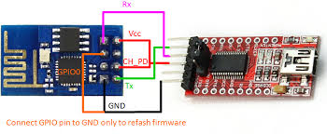

[934 × 384 - importhack.wordpress.com](http://www.google.com/imgres?imgurl=https://importhack.files.wordpress.com/2014/11/esp8266-reflash-firmware.png&imgrefurl=https://importhack.wordpress.com/2014/11/22/how-to-use-ep8266-esp-01-as-a-sensor-web-client/&h=384&w=934&tbnid=DRqblNUbySGLtM:&docid=GM5zMKVCt314wM&ei=9gBQVu8vie2YAceMicAO&tbm=isch&ved=0ahUKEwjvgqeV5KDJAhWJNiYKHUdGAugQMwgdKAAwAA)

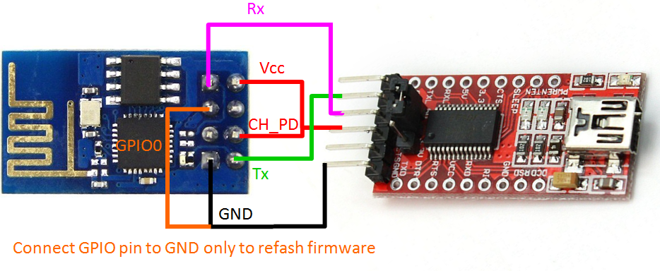

One more thing I ran across seems to be a basic interpreter for the ESP8266

<http://www.esp8266basic.com/>